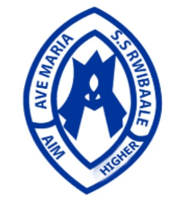

**AVE MARIA SECONDARY SCHOOL**

**Document Placeholder**

1. **Welcome to Ave Maria Secondary School**

We are delighted to have you visit our website. This document serves as a placeholder for downloadable resources such as past examination papers, assignments, and other educational materials. We apologize for any inconvenience caused and appreciate your understanding.

1. **Why This Document?**

This placeholder ensures that you are informed that the specific document you attempted to download is currently unavailable or under maintenance.

1. **Next Steps**
2. **Check Back Later:** Our website is continually updated.
3. **Contact Us:** For immediate assistance or specific requests, please use the contact information below.
4. **Contact Information**

**Address:**  
Ave Maria Secondary School  
5634 Education Lane, Rwibale, Kyenjojo

**Phone:**  
+256 761190732

**Email:**  
[info@avemariasecondary.edu](mailto:info@avemariasecondary.edu)

**Website:**  
[www.avemariasecondary.edu](http://www.avemariasecondary.edu/)

1. **Stay Connected**

Follow us on social media for the latest updates:

* **Facebook:** [Ave Maria Secondary School](http://www.facebook.com/avemariasecondary)
* **Twitter:** [@AveMariaSecondary](http://www.twitter.com/avemariasecondary)
* **Instagram:** [@AveMariaSecondary](http://www.instagram.com/avemariasecondary)

1. **Thank You for Your Patience**